**The Gambia country profile**

Published

14 February 2018

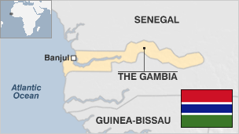

**The Gambia is one of Africa's smallest countries and, unlike many of its west Africa neighbours, has enjoyed long spells of stability since independence.**

President Yahya Jammeh ruled the country with an iron fist after seizing power in a bloodless coup in 1994. His 22-year rule came to an end in 2016, when he was defeated in a shock election result by the main opposition candidate, Adama Barrow. Mr Jammeh only left office after mediation by neighbouring countries and the threat of armed intervention.

Stability has not translated into prosperity. Despite the presence of the Gambia River, which runs through the middle of the country, only one-sixth of the land is arable and poor soil quality has led to the predominance of one crop - peanuts.

Tourism is an important source of foreign exchange, as is the money sent home by Gambians living abroad. Most visitors are drawn to the resorts that occupy a stretch of the Atlantic coast.

* Read more [country profiles](http://news.bbc.co.uk/1/hi/country_profiles/) - Profiles by [BBC Monitoring](http://bbc.co.uk/monitoring)

**President: Adama Barrow**

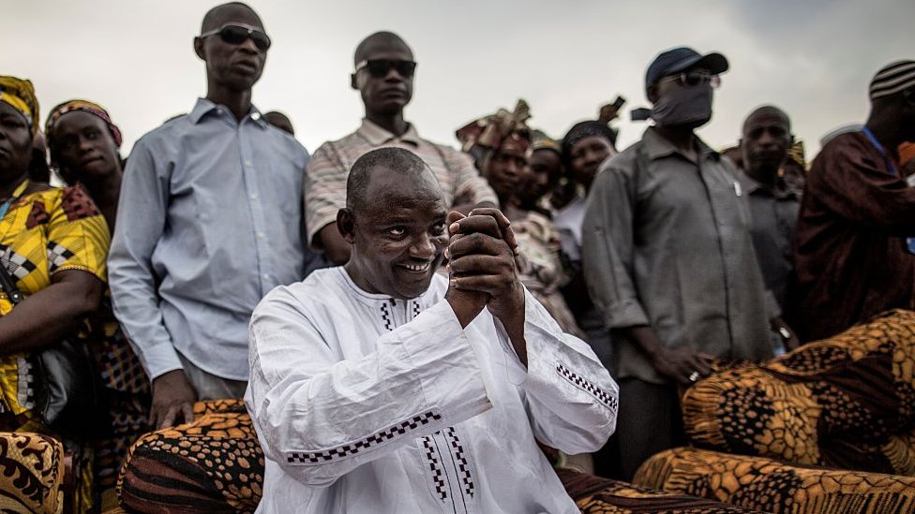image copyrightAFP

Adama Barrow defeated long-serving President Yahya Jammeh in a shock election victory in December 2016.

Mr Barrow, a property developer, ended Yahya Jammeh's 22-year authoritarian rule by winning more than 45% of the vote.

A member of the United Democratic Party, during his election campaign Mr Barrow pledged to revive the country's economy.

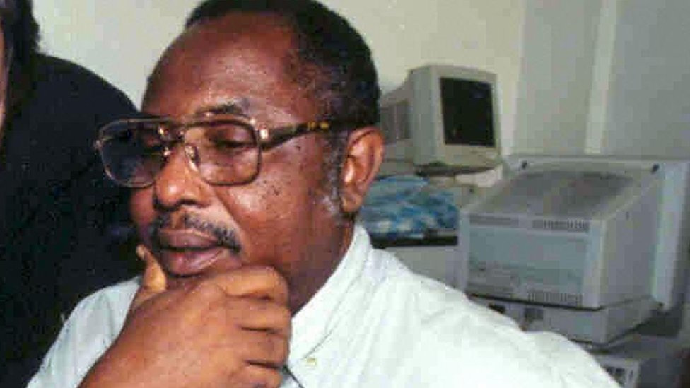image copyrightGetty Images

image captionThe Jammeh government was accused of failing to properly investigate the killing of journalist Deyda Hydra in 2004

Adama Barrow's inauguration as president in 2017, ending 22 years of rule by former leader Yahya Jammeh, raised hopes of a new era of respect for media freedom, says Reporters Without Borders (RSF).

RSF says the former president oversaw a "climate of terror" for the media.

# The Gambia profile - Timeline

Published

14 February 2018

## A chronology of key events:

**1455** - Portuguese establish trading stations along Gambia river.

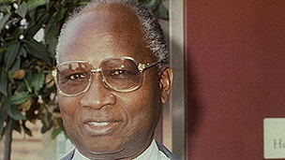image copyrightvisnews

image captionDawda Jawara was prime minister at independence and was ousted in 1994

**1889** - Present boundaries of The Gambia set by agreement between Britain and France.

**1894** - The Gambia becomes a British protectorate.

**1965** - The Gambia becomes independent with Dawda Jawara as prime minister.

**1970** - The Gambia becomes a republic following a referendum; Mr Jawara elected president.

**1981** - Five hundred people are killed as Senegalese troops help suppress a coup.

**1982** - The Gambia and Senegal form a loose confederation called Senegambia, which collapses in 1989.

## Coup

**1994** - President Jawara ousted in coup led by Lieutenant Yahya Jammeh.

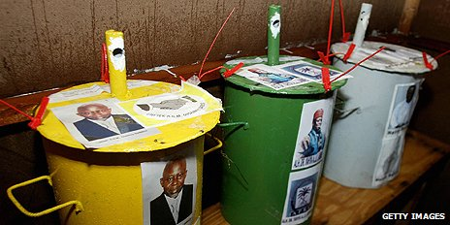image copyrightGetty Images

image captionGambia has an unusual voting system in which voters deposit marbles into a steel drum marked with the candidate of their choice

**1996** - New multiparty constitution promulgated, but three major political parties still banned from taking part in elections; Jammeh elected president.

**2001 23** July - President Jammeh lifts the ban on the political parties he overthrew in his military coup of 1994.

**Second term for Jammeh**

**2001** October - President Jammeh wins a second term. Foreign observers give the poll a clean bill of health in spite of rising tension ahead of the vote.

**2002** May - Opposition MPs and journalists condemn a new media law, passed by parliament, as draconian and intended to muzzle the independent press.

**2004** February - President Jammeh announces the discovery of large reserves of oil.

**2004** December - New press law provides for the jailing of journalists found guilty of libel, sedition. Days later a critic of the law, prominent editor Deyda Hydara, is shot dead.

**2006** August - Thousands flee into Gambia from Senegal's southern Casamance region to escape fighting between Senegalese troops and separatists.

**Third Jammeh term**

**2006** September - President Jammeh wins a third term.

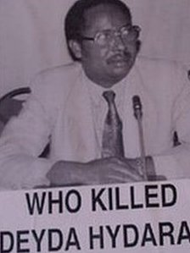

image captionDeyda Hydara, a critic of strict media laws, was murdered in 2004. Others journalists have gone missing or have been jailed

**2007** February - UN development envoy Fadzai Gwaradzimba is expelled for criticizing the president's assertion that he can cure AIDS.

**2008** May - President Yahya Jammeh tells a rally that he would "cut off the head" of any homosexual found in The Gambia, prompting an outcry from international gay rights campaigners.

**2009** March - Amnesty International says hundreds have been kidnapped during a government campaign against "witchcraft".

**2009** September - President Jammeh threatens to kill human rights workers as saboteurs.

**2010** October - Death penalty introduced for possession of cocaine or heroin in a bid to discourage international drug trafficking.

## Fourth Jammeh Term

**2011** November - President Jammeh wins another term in widely criticised elections.

**2012** June - Ex-justice minister Fatou Bensouda is sworn in as the International Criminal Court's new chief prosecutor in The Hague.

**2013** October - President Jammeh announces Gambia's withdrawal from the Commonwealth, describing it as a "neo-colonial institution".

**2015** January - Dozens of soldiers and civilians are arrested following December foiled coup bid.

**2016** Summer - Government carries out crackdown on political opponents ahead of December elections. Opposition party member Ebrima Solo Kurumah dies in custody in August.

## End of Jammeh's rule

**2017** January - President Jammeh goes into exile after losing December election to opposition candidate Adama Barrow, but only after neighbouring countries threaten military intervention.

**2017** April - Parliamentary elections give an absolute majority to the United Democratic Party. It trounced the APRC - the dominant party under Yahya Jammeh's rule.